**INTRODUCTION**

The game, “**Jack, The Savior!**” is a text-based game where the player needs to input certain text data to continue playing. The text data will be processed and according to the input further actions will decide by the game management system. The game is basically designed and developed using Unity game development platform and using C# for programming.

The text-based environment is made possible in game by creating questioning and answering session between the player and system. The player will have certain health while starting the game and will be reduced by certain amount when the player answered wrongly. The game will start by explaining game situation and then the player can start the game.

There are various approaches exists now for creating game applications, such as:

* Model View Controller (MVC)
* Model View Template (MVT)
* Model View View/Model (MVVM)

etc..

Each approach has their own strength and weakness towards the development. Here I am going to utilize Model View View/Model approach which is also known as MVVM architecture. More details regarding MVVM will be discussed in the later part.

The game is a 2-dimensional (2D) game which supports multiplayer facility. Multiple players can join the game and the winner will be those who finish the game first and with most health.

**MODEL-VIEW-VIEWMODEL ARCHITECTURE**

As the technology more emerge the need of effective and fast development process is inevitable. By making it possible it is also relevant to keep the system simple without being much complexity. To reduce the complexity of a system patterns are good and effective solution. Model-View-ViewModel or MVVM is one of the several patterns or approaches now using. Here the abstract flow is Model 🡨🡪ViewModel 🡨🡪View.

In traditional User Interface development, developer need to create a view using available window functionalities or similar process and will write all logical implementation. This makes the View large which then creates a strong dependency between UI and binding logic. This led to complex situation in working as team environment and keeping all code in one are leads to ineffective maintainability. This mainly happens because of the tight coupling between the view and logic which includes both business logic, event handling and data binding.

MVVM pattern usually takes advantages of device capabilities and thus it makes use of device memory to extend the application performance. Thus, it allows better user experience which then allows then to have the application on various devices which has varying screen size. MVVM enables the separation of graphical UI from business logic.

* **Model**: It represents the actual data or information that the application deals with. Here in the game the text which moves the story and game is stored using the game models.
* **View**: It is the most familiar part of any system. Here is where the end users really interact with. This visualizes data in a presentable way according to the nature or data and the way user needs it. The view has no knowledge or information about the model. It is fully controlled by a controller. It is where the player interacts with the game. Simple the game interface.
* **ViewModel**: It is what enables the view using the models available. It converts the data to presentable format instead of letting the model aware of user view. In game it is what which accepts the input from the user and then process it for further actions/moves.

**GAME DESCRIPTION**

“**Jack, The Savior!**” is a fun and best game for children since it doesn’t involve any violent actions or behaviors which will affect the mind of children. The questions designed for the game is similar to brain teaser which helps the children to think more and thus, they can develop their problem-solving skills.

The player has 2 option to play the game. Either the player can start a new game or join some random game. Joining some random game is like joining a game where other players are playing the game thus, those players may have more advantage than the later joined player since they joined earlier.

The game story is as follows.

Once there lived a bunny, Jack with his parents Will and Pink in a village very close to a jungle. In the deep jungle there also lived a fearsome monster in a castle who preyed on innocent animals. One day, Will and Pink along with their neighbor Tinku duck went to jungle in search of food and firewood. They couldn’t find enough food in the outer jungle, so they went deep into the forest. Suddenly they found a garden full of fruits and vegetables and they ran into the garden to pick some. They didn’t know that it was the monster’s garden. By that time the monster came back from his hunting. He found these three uninvited animals in his garden and got angry. He rushed to the garden and caught Will and Pick. Tinku somehow managed to escape from the monster and ran back to the village. He explained everything to Jack and told that only the ones who are blood related can go into the castle and save them. Jack took on oath that he will save his parents by any means.

The game starts here, the player will play the role of Jack. In-order to get inside of the castle successfully the player need to complete 5 levels. Each level will have certain questions to answer. Passing each level successfully will help the player move further inside of the castle and when all the levels are passed the player will be inside of the castle and the monster will release the parents. The player needs to complete all the tasks before he loses his all health.

When the player will start the game, 10 hearts are given as health. Each wrong answer in the game session will reduce 2 hearts. Hence 5 wrong answers will drain all the health and the player will lose the game.

The whole game is divided into 5 levels. Each level has 3 questions to answer. The difficulty level of each question will increase as the game progress.

The game consists of mainly 6 scenes including game room and certain dialog boxes to show information, warning, danger messages.

* Login scene
  + This scene is loaded first when the game application is loaded. It enables the user to login into the system.
* Register scene
  + This allows new users to create profile in the system.
* Dashboard scene
  + This provides the game story outline and options to start a new game or to join a random game.
* Character Interaction scene
  + This scene will load when the player starts playing the game where Jack and Tinku is exchanging their dialogues.
* Game Room
  + The actual game will run here in game room. The game room is where the game system interacts with the player.
* Co-player detail scene
  + This scene will provide the details of co-players, like their health and level details. The Co-player details scene will show when the player joined a random game and whenever the player needs he/she can open it through Game Room.

UI components used for designing the game are

* Image
* Text
* Input Field
* Scrollbar
* Buttons

Each component and buttons used in the design will be explained in the below storyboard.

The interactive session of the game is like a quiz where the system will ask questions and the player need to answer these. The player can move further only if he/she is able to answer correctly. Incorrect answer will reduce the health by 2 hearts. Hence it is very important to answer correctly.

Since the game focuses on the question answer interaction this will be a great choice for students. The game questions can be changed according to the level of children, this is made possible since the game use questions which is saved in a remote database. Hence, the game can be extended to a greater level when an interface is created to implement the questions by the user according to the end level users.

**STORYBOARD & DESCRIPTION**

Storyboard is a graphical organizer of the application which needs to be developed. These graphical representations can be visualized in the form of illustrations or images in a sequence which happens in the application. This graphical visualization helps the developers to initiate the development process with the basic design which can be maintained throughout the development. This gives a visual idea on how the game is playing and thus the developers will be able to develop the application real time without having confusion in the design part.

It is a quick way of getting a perspective into what the game will look like prior to the production even before a prototype is developed and tested. These storyboards will help to see where there are gaps in the gameplay actions which will help to give richer experience for the game. While giving the storyboard it is very important to organize it in the proper way so that it will depend on the precise goals of storyboard session.

With storyboard it is equally important to describe what is happening in the storyboard. Storyboard includes the story background of game and the elements required for the game progress. These elements are initiated with the help of user actions. Hence it is essential to describe what will happen when the user initiates the action.

Advantages of storyboard and description are:

1. Will get an overview of the application just with a look.
2. Can improvise the design ideas.
3. Provides concise information.
4. Clear idea about the system before its development

Below explains the story board of game application and the descriptions of user actions related to the game.

**1. Login**

**Board 1**

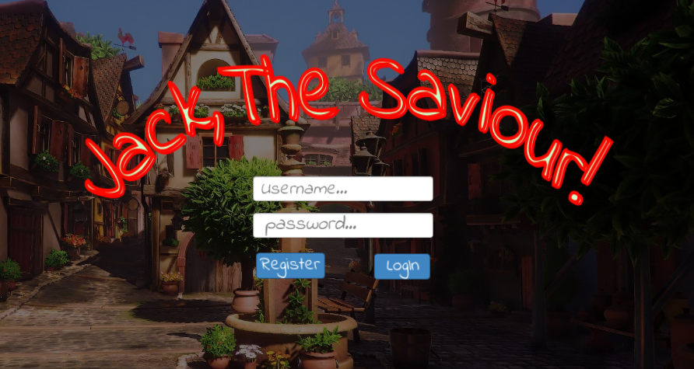

The player need login to the system before start playing the game. Only registered player can login successfully.

|  |  |  |  |  |
| --- | --- | --- | --- | --- |
| Action | What happens? | | | Where to? |
| Click Login | 1. Check if user exists or not? | | |  |
|  | 1.1. If not, throw an error saying so. | | Go to board 2 |
|  | 1.2. If exists, then validate username & password | |  |
|  |  | 1.2.1. If validation success | Go to board 3 |
|  |  | 1.2.2. If validation fails, throw error message and stay in the same login page |  |
| Click Register | 1. Opens registration page | | | Go to board 2 |
| Click native back button | Closes the application | | |  |

**2. Register**

**Board 2**

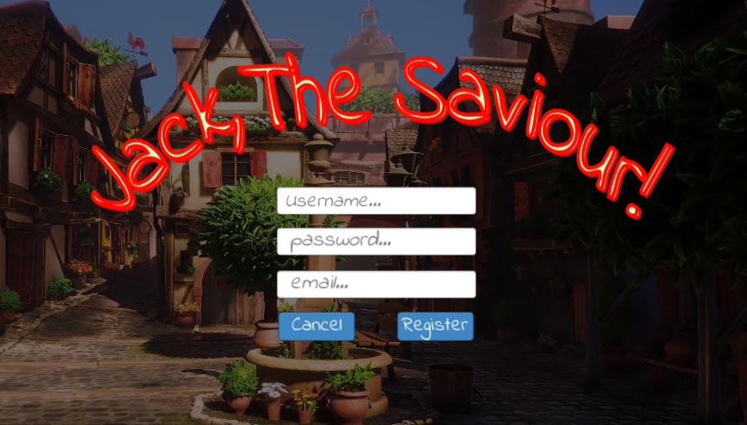

Only registered player can login and play the game. The username should not be a already taken one.

|  |  |  |  |  |
| --- | --- | --- | --- | --- |
| Action | What happens? | | | Where to? |
| Click Register | 1. Check if user exists or not? | | |  |
|  | 1.1. If exists, throw an error saying so. | |  |
|  | 1.2. If not check whether all fields are filled or not | |  |
|  |  | 1.2.1. If not, throw an error saying so |  |
|  |  | 1.2.2. If all fields are filled then register the new user details | Go to board 1 |
| Click Cancel | 1. Navigate back to login page | | | Go to board 1 |
| Click native back button |

**3. Game Home**

**Board 3**

Log out

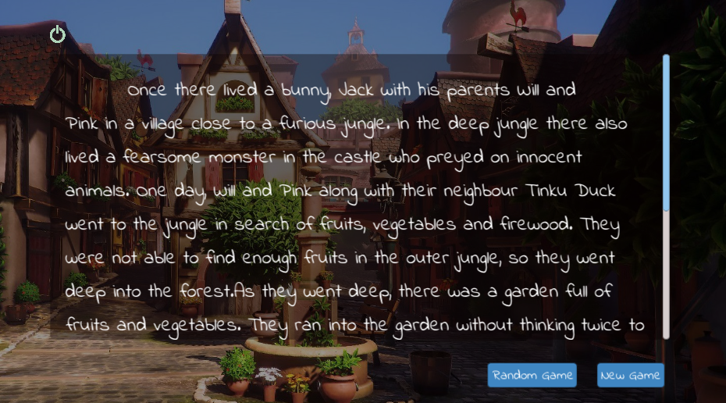

Story area

Once the player is successfully login, the game home will load. Game home will describe the basic story outline and actions to start game, join some random game and log out.

|  |  |  |
| --- | --- | --- |
| Action | What happens? | Where to? |
| Click New Game | 1. New game will create | Board 4 |
| Click Random Game | 1. The player will join in some random game | Board 4 |
| Click Logout | 2. The player will be logged out | Board 1 |

**4. Character Interaction**

**Board 4**

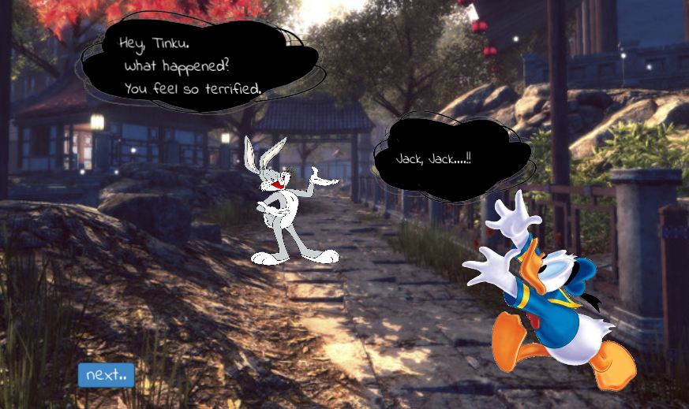

The character interaction screen is where the characters of the game will interact each other. The main dialogue delivery is that the Tinku duck explains the situation happened in the jungle to Jack so that the Jack will get clear about it.

Clicking Next button will trigger the dialogue delivery once all the dialogues are finished clicking Next button will open the Game Room.

**5. Game Room**

**Board 5**

Timer

Hearts

Menu

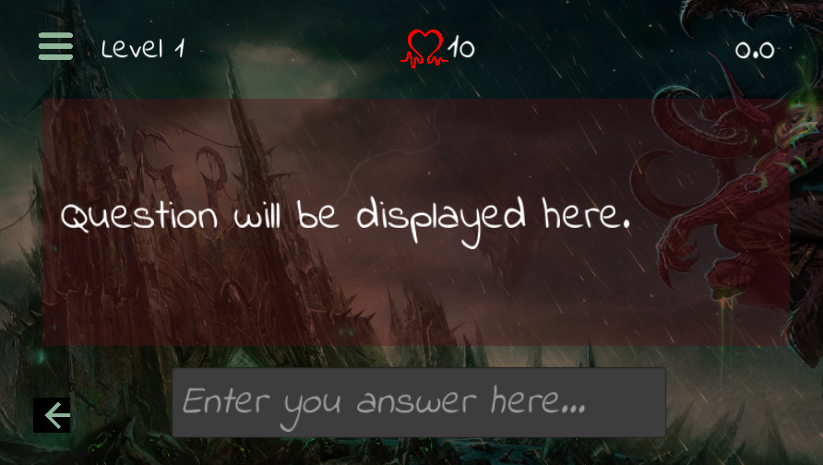

Game will ask question here

Player will input answer here

Back to Game Home

Once the game starts the interaction between player and game will happen here. The game will ask questions and player will answer.

|  |  |  |
| --- | --- | --- |
| Action | What happens? | Where to? |
| Click Menu | 1. Co-Player details will show | Board 6 |
| Click Back | 1. The player will navigate back to the Game Home | Board 3 |

**6. Co-Players Details**

**Board 6**

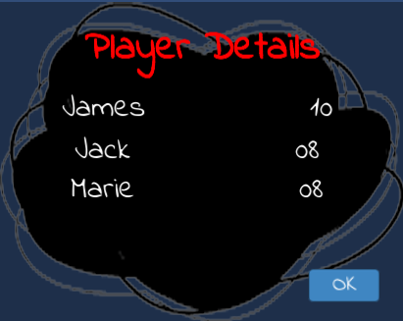

The co-players details will be shown here when clicking menu button in Game Room. Clicking OK button will close the detail page.

**7. Game Room Message**

**Board 7**

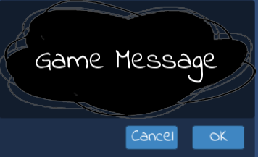

All the game related messages will show in the above message scene.

**USE-CASE DIAGRAM**

Use-Case diagram is a graphical interface to depict the interaction between actors and system in a most simple and efficient way. The main aim to identify, clarify and organize various requirements required for the system to design. In-order to deploy use case, UML is used which is a standard notation for the mapping of real-world objects and systems. It helps to analyze various scenarios as well as scope of the system.

If the requirement to analyze the system in a deep nature, use-case is not a good choice. It depicts only a high-level overview of the relation between actors and system.

In-order to draw a use-case diagram, it is essential to have a understanding of basic building blocks.

* Actors: Actors are those who interact with the system. It can be a person, an organization or even can be an external system who tries to interact.
* System: System can be considered as a scenario happening between actors and the system.
* Goals: It is what the final aim of use-case, it should describe the while activities to reach the goal.

Here, we mentioned below symbols and notations to represent use-case for the required scenario.

* Use cases are represented using horizontally shaped ovals.
* Actors are represented by stick figures



*  Dependencies are represented by dashed line & Association with a straight line



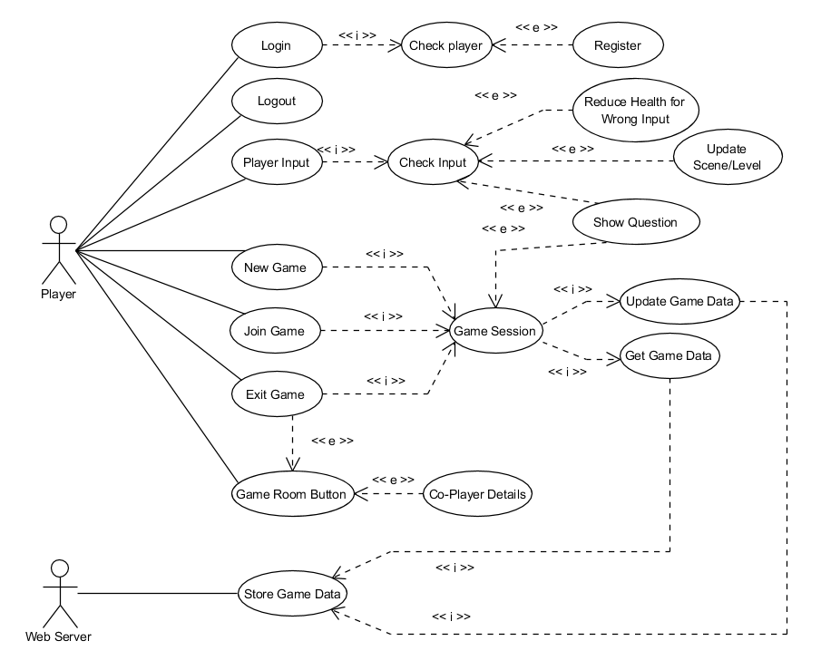

Figure Use-Case Diagram